**HAJA ALAWUDEEN HAJA KUTHUBUDEEN**

Email: [hajasakeep@gmail.com](mailto:hajasakeep@gmail.com) Mobile: - 0094 –75–7302426

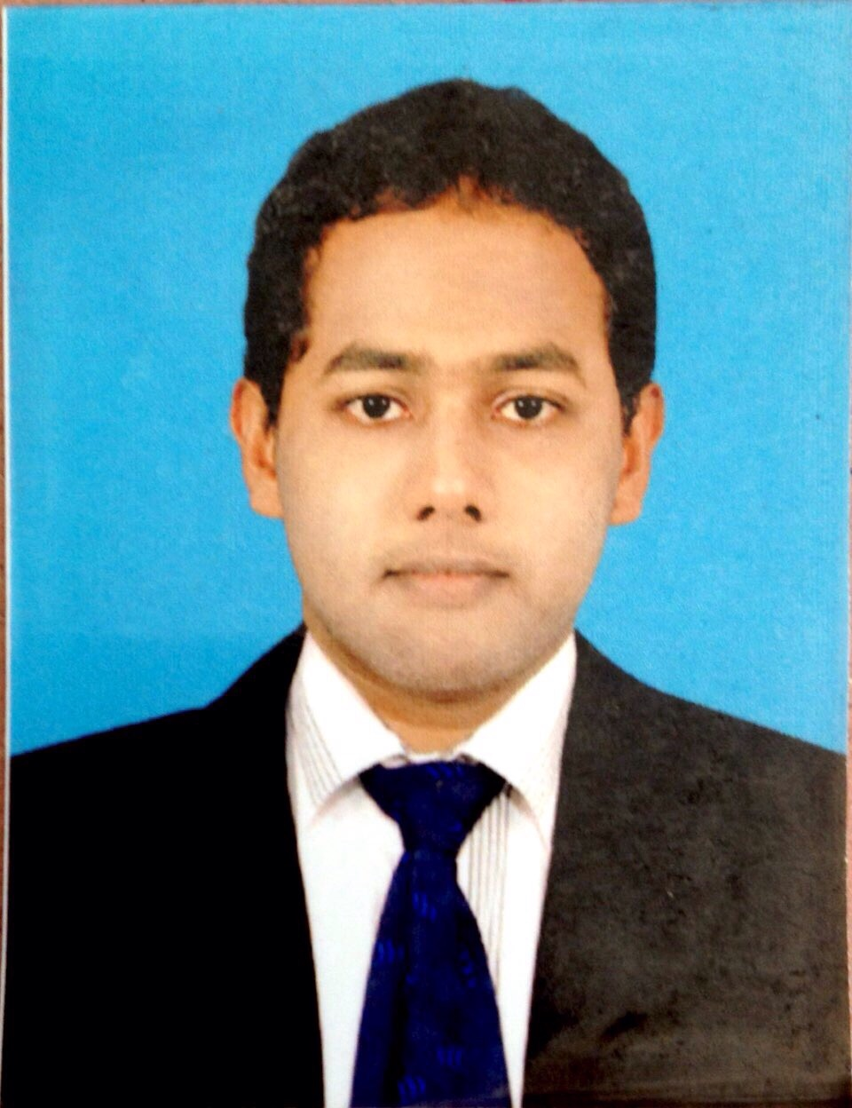

**Permanent Address:**

140,Old Cinema Road,

Akkaraipatthu-01 Srilanka

**Personal Data:**

Name:

Haja Kuthubudeen

Date of Birth:

15 / 03 / 1991



Gender: Male. Nationality: Sri Lankan. Religion: Islam

Marital Status:

Single

P.P. Number:

N5619233

D.L. Number:

B2093778

To pursue a highly rewarding career, seeking for a job in challenging and healthy work environment where I can utilize my skills and knowledge efficiently for organizational growth..

Educational Qualification:

* General Certificate of Education Ordinary Level ( O/L) passed in 2007

**Other Qualification:**

* **Successfully completed Diploma in Computerized Accounting**

At PAC Lanka Campus in Sri Lanka

* **Successfully completed Diploma in Computer Hardware Engineering**

At British Informatics of Computer Technology **(BICT)** inSri Lanka

* **Successfully completed Certificate in Computer Application Assistant** at PAC Lanka Campus in Srilanka.
* **Successfully completed Diploma in English**

At PAC Lanka Campus in Sri Lanka

**Personal Stregnth**

* Analytical thinking, planning.
* Strong verbal and personal communication skills.
* Accuracy and Attention to details.
* Organization and prioritization skills.
* Problem analysis, use of judgment and ability to solve problems efficiently.
* Self motivated, initiative, high level of energy.
* Decision making, critical thinking, organizing and planning.
* Tolerant and flexible to different situations.
* Hard work, honesty, confident and creative.

**Career Objective:**

**KEY SKILLS**

* **System Administration**
* **Network Administration**
* **Firewalls**
* **Information Security**
* **Network Security**
* **Windows servers**
* **Microsoft Office 2010**
* **Windows Xp, Wista, Win7 and Win8**
* **Peachtree Accounting**
* **Quick Book Accounts.**
* **Tally Accounts.**
* **Myob Accounts.**

**Hobbies**



* Internet Surfing

**Work Experiences**

* Worked for IT.Com in Srilanka as a **Computer Hardware and Technical support**. From: Jan 2009 to April 2015

**Key Responsibilities handled:**

•Computer assembling and maintenance.

•Troubleshooting hardware and software problems solving

•Installing and configuring the peripherals, components and drivers

•Installing software and application

•Configuring and troubleshooting desktops, laptops and servers

**Declaration**

**I hereby declare the above stated information’s are true and accurate to the best of my knowledge and belief, if given a chance I can prove myself.**

Your faithfully **H. A. H. Kuthubudeen**